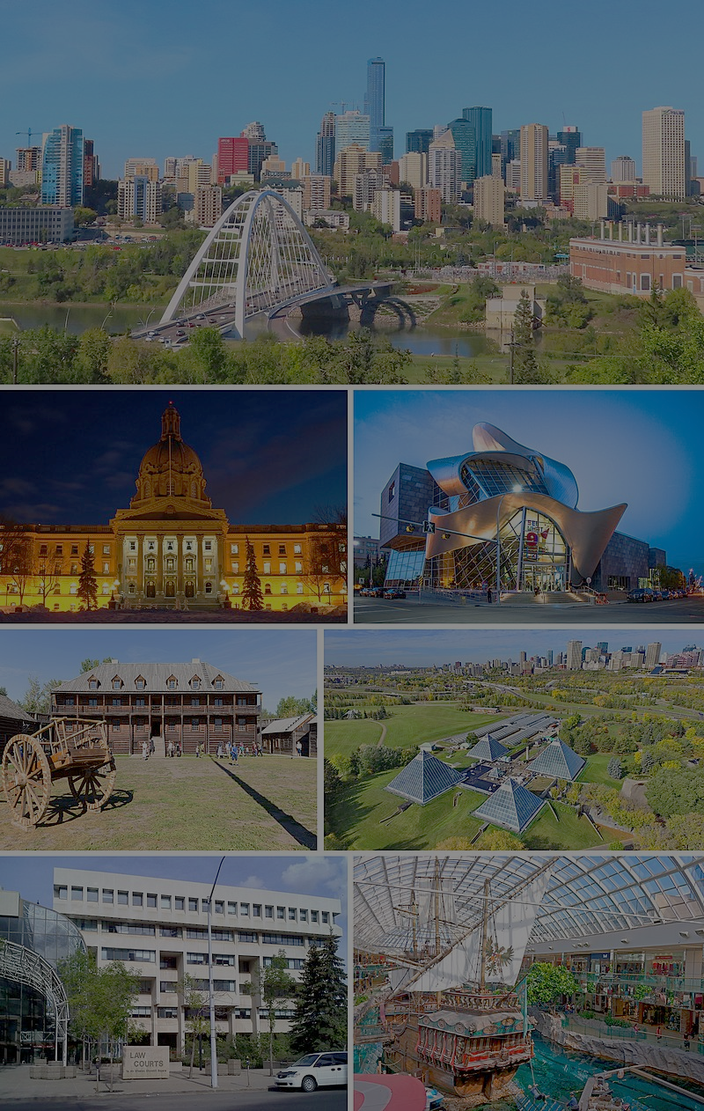**The Battle of Neighborhoods: Edmonton's Best Neighborhood**

**By Armin Norouzi**

**Abstract:**

In this project, first, the investigation on Alberta Capital city has been done to determine which neighborhood has the best neighborhood to live in. To analyze this, Data from Wikipedia has been used to generate Edmonton Neibhouds location information. Then, Foursquare API is employed to create a venue nearby each location. In the end, three more desirable neighborhoods based on the number of venue prospects have been identified.

1. **Introduction:**

Edmonton is the capital city of the Canadian province of Alberta. Edmonton is on the North Saskatchewan River and is the center of the Edmonton Metropolitan Region, surrounded by Alberta's central region. The city anchors the north end of what Statistics Canada defines as the "Calgary–Edmonton Corridor."

Edmonton's metro area had a population of 1,491,000 at the beginning of 2021, making it Alberta's second-largest city (after Calgary) and Canada's fifth-largest municipality. Edmonton's 2019 municipal census subsequently recorded a population of 972,223. In 2016, Edmonton had a metropolitan population of 1,321,426, making it the sixth-largest census metropolitan area (CMA) in Canada. Edmonton is North America's northernmost metro area with a population of over one million. A resident of Edmonton is known as an Edmontonian.

Edmonton's historic growth has been facilitated through the absorption of five adjacent urban municipalities (Strathcona, North Edmonton, West Edmonton, Beverly, and Jasper Place) in addition to a series of annexations through 1982 and the annexation of 8,260 ha (82.6 km2) of land from Leduc County and the City of Beaumont on January 1, 2019. Known as the "Gateway to the North," [18] the city is a staging point for large-scale oil sand projects in northern Alberta and large-scale diamond mining operations in the Northwest Territories.

Edmonton is a cultural, governmental, and educational center. It hosts a year-round slate of festivals, reflected in the nickname "Canada's Festival City." It is home to North America's largest mall, West Edmonton Mall (the world's largest mall from 1981 until 2004), and Fort Edmonton Park, Canada's largest living history museum.

The primary purpose of this project is to help people in exploring better facilities around their neighborhood. It will help people making wise and efficient decisions on selecting significant areas out of numbers of other neighborhoods in Edmonton, Alberta.

This project aims to analyze features for people migrating to Edmonton to search the best neighborhood as a comparative analysis between neighborhoods. The features include median housing price and better school according to ratings, crime rates of that particular area, road connectivity, weather conditions, good management for an emergency, water resources both fresh and wastewater, and excrement conveyed in sewers and recreational facilities.

It will help people to get the awareness of the area and neighborhood before moving to a new city, state, country, or place for their work or to start a new fresh life.

1. **Data mining**

For this project, we need the following data:

* New York City data that contains list Boroughs, Neighbourhoods along with their latitude and longitude.
* Data source: https://en.wikipedia.org/wiki/List_of_postal_codes_of_Canada:_T
* Description: This data set includes the required information. And we will use this data set to explore various neighborhoods of Edmonton, AB, Canada
* Venue information in each neighborhood of Edmonton.
* Data source: Foursquare API
* Description: By using this API, we will get all the venues in each neighborhood. We can filter these venues to get only Indian restaurants.
* GeoSpace data
* Data source: <https://data.cityofnewyork.us/City-Government/Borough-Boundaries/tqmj-j8zm>
* Description: Using this geospace data, we will get the Edmonton Borough boundaries to visualize the choropleth map.

1. **Research Question**

This project's primary purpose is to suggest a better neighborhood in a new city for the person who is shifting there. Social presence in society in terms of like-minded people. Connectivity to the airport, bus stand, city center, markets, and other daily needs things nearby.

Edmonton is a popular destination for new immigrants in Canada to reside. As a result, it is one of the most diverse and multicultural areas in the Greater Edmonton Area, being home to various religious groups and worship places. Although immigration has become a hot topic over the past few years, with more governments seeking more restrictions on immigrants and refugees, Canada's general immigration trend has been one on the rise.

This project would use Four-square API as its prime data gathering source as it has a database of millions of places, especially their sites API, which provides the ability to perform location search, location sharing, and details about a business.

1. **Work Flow**

Using credentials of Foursquare API, features of nearby places of the neighborhoods would be mined. Due to HTTP request limitations, the number of classes per neighborhood parameter would reasonably be set to 100, and the radius parameter would be set to 700.

1. **Methodology**
   1. **Clustering Approach**

To compare the similarities of the two cities, we decided to explore neighborhoods, segment them, and group them into clusters to find similar neighborhoods in big cities like New York and Toronto. To be able to do that, we need to cluster data which is a form of unsupervised machine learning: k-means clustering algorithm

* 1. **Libraries Which are Used to Develop the Project**

In this project, various Packages have been used that can be listed here:

* Pandas: For creating and manipulating data frames.
* Folium: Python visualization library would visualize the neighborhood cluster distribution using an interactive leaflet map.
* Scikit Learn: For importing k-means clustering.
* JSON: Library to handle JSON files.
* XML: To separate data from presentation and XML stores data in plain text format.
* Geocoder: To retrieve Location Data.
* Beautiful Soup and Requests: To scrap and library to handle HTTP requests.
* Matplotlib: Python Plotting Module.

1. **Results and Discussions**
   1. **Best Neighborhood**

Alberta Neibhoud and in different cities is shown in Figure 1.

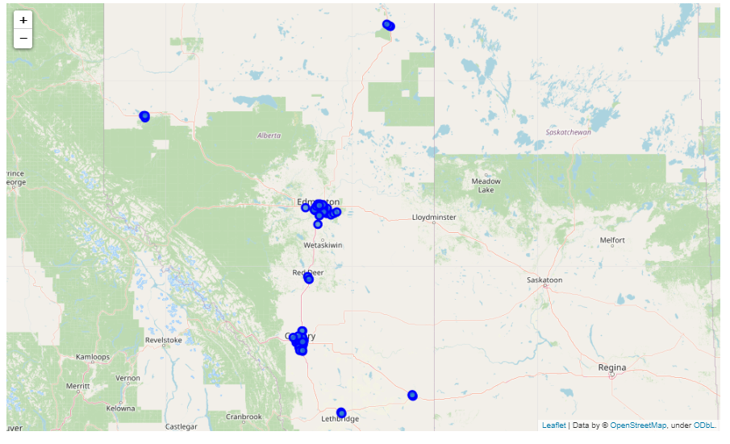

Figure 1- Alberta Map

As the main objective of this project is to focus on Alberta's capital city, we choose only postal codes that include Edmonton in their Borough. The results are shown as follow:

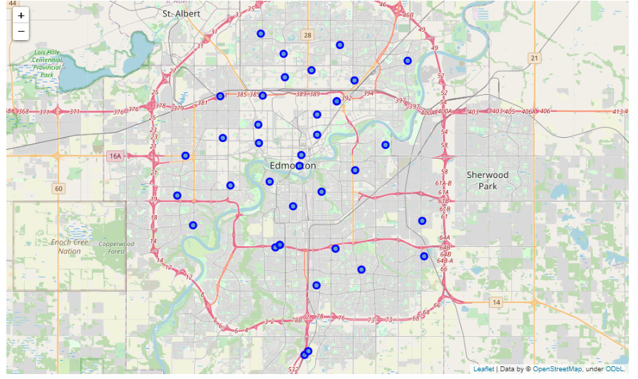

Figure 2- Edmonton Map

Then Foursquare API is employed to find the best neighborhood of Edmonton based on the number of venues. The following table shows the number of venus in 500 meters radius of each neighborhood.

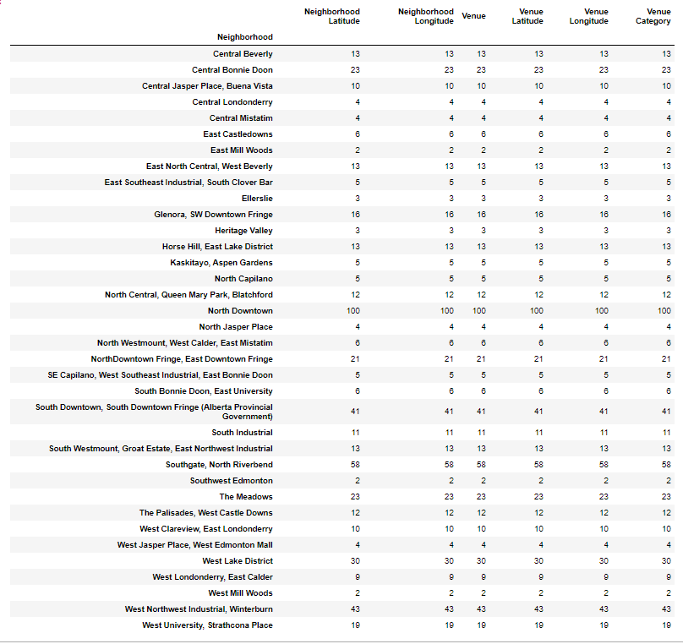

Based on this table, North Downtown has thehighest number of venue.

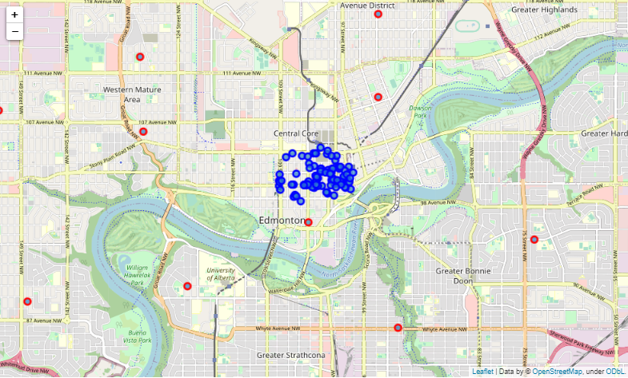

Figure 3- North Downtown Venus

These venus has been shown in the map in Figure 3. The top ten categories of these venues are listed as follow:

|  |  |
| --- | --- |
| **Venue category** | **Number in each category** |
| Coffee Shop | 9 |
| Sandwich Place | 5 |
| Pub  Café  Hotel | 4 |
| Restaurant  French Restaurant | 3 |
| Pizza Place  New American Restaurant  Rock Club  Brewery  Gym  Nightclub  Smoothie Shop  Asian Restaurant  Vietnamese Restaurant  Bar  Mexican Restaurant  Steakhouse | 2 |

* 1. **Most Common venues near neighborhood**

In this study, K-means algorithms are used to find the most common Neibearhouds. The results are shown in Figure 4. As shown, almost all the neighborhood has the same categories of venues all around the city that make this city desirable. It does not matter which part of the city are you living in, you have access to every venue.

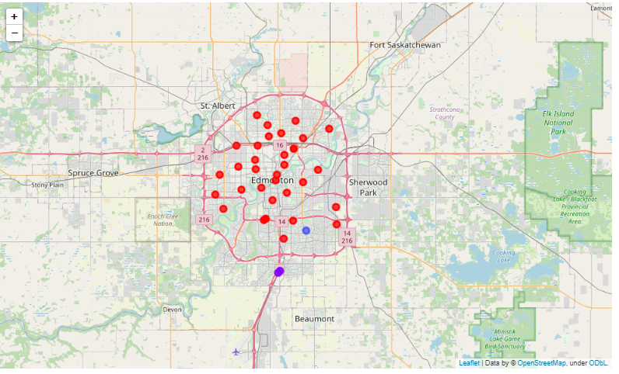

Figure 4- Clustering results